***Screenshots.docx*** *This file is written with open-source LibreOffice Writer.  
February 2023*

**Table of Contents**

1. Project code structures in Eclipse IDE 2

2 Run the program in IDE 3

3. User select [1] list all files 4

4. Select [2] for Business Operations sub-menu 4

5. Select sub-menu [4] return to Main Welcome Menu 6

6. Main menu, select [3] to exit program 7

7. Business operation sub-menu, select [1] add a file, file already exists error 8

8. Business operation sub-menu , select [1] add a file, successful create a new file 9

9. Business operation sub-menu , select [2] delete a file, file not found, no deletion 10

10. Delete a file , case-sensitive , miss-match as case-sensitive, no deletion 11

11. Delete a file , exact match , delete successfully 12

12. Business operation sub-menu [3], Search user specified file, success search 13

13. Sub-menu [3] , Search case-sensitive , miss-match , file not found 14

14. Sub-menu [4], return to Main Welcome Menu 15

15. All operations exclude sub-directories , only applied to files 16

16. Main menu, user input outside of range , prompt to re-select 17

17. Business Operation sub-menu , user input out of range , prompt to re-select 18

18. Remote git-hub and local repository 19

19. GitHub link, 19

# 1. Project code structures in Eclipse IDE

**Source-code files Function**

src/com/WelcomeStartMenu.java ---------- Welcome Menu

/BusinessOperation.java ---------- Business Operation Menu

/DeleteFile.java ---------- Delete a user specified file (case sensitive)

/ListFiles.java ---------- List files in ascending order

/SearchFile.java ---------- Search user specified file (case sensitive)

/AddFile.java ---------- Adding a user specified file (case in-sensitive)

FileStorage/dir-a test sub-directory   
 /dir-brc sub-directory   
 /aa1.txt test file   
 /... ....

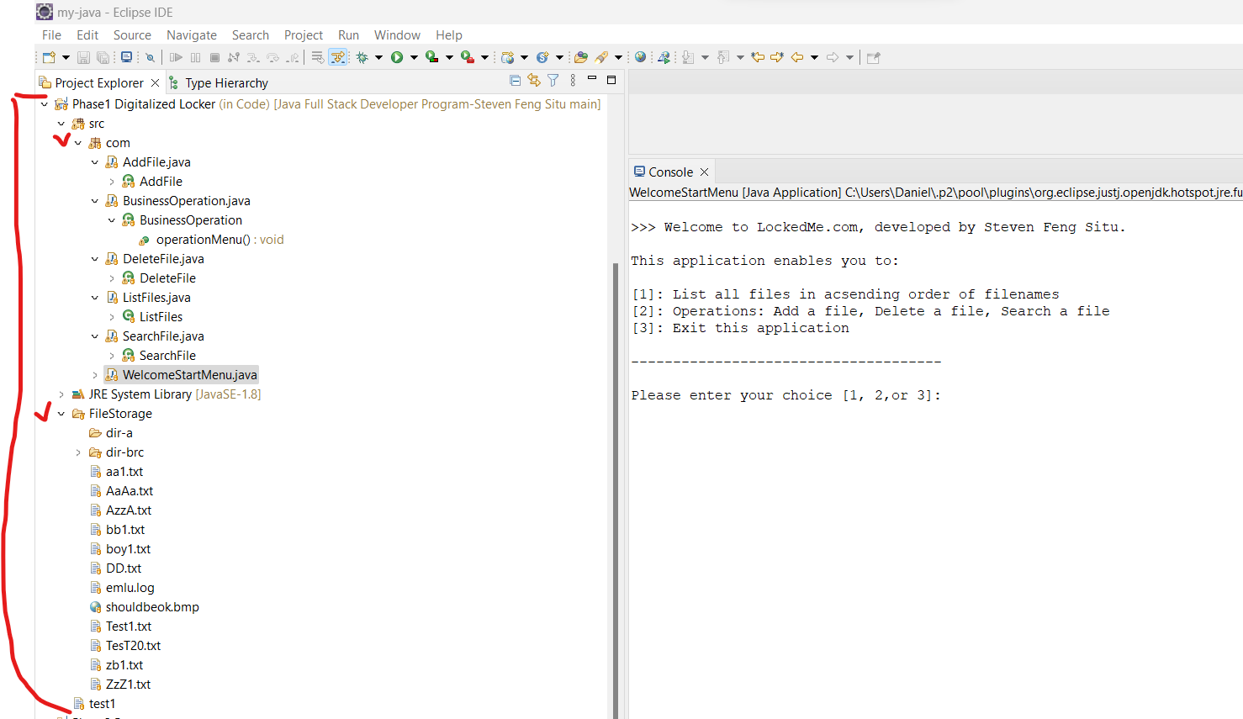

# 2 Run the program in IDE

Welcome Menu

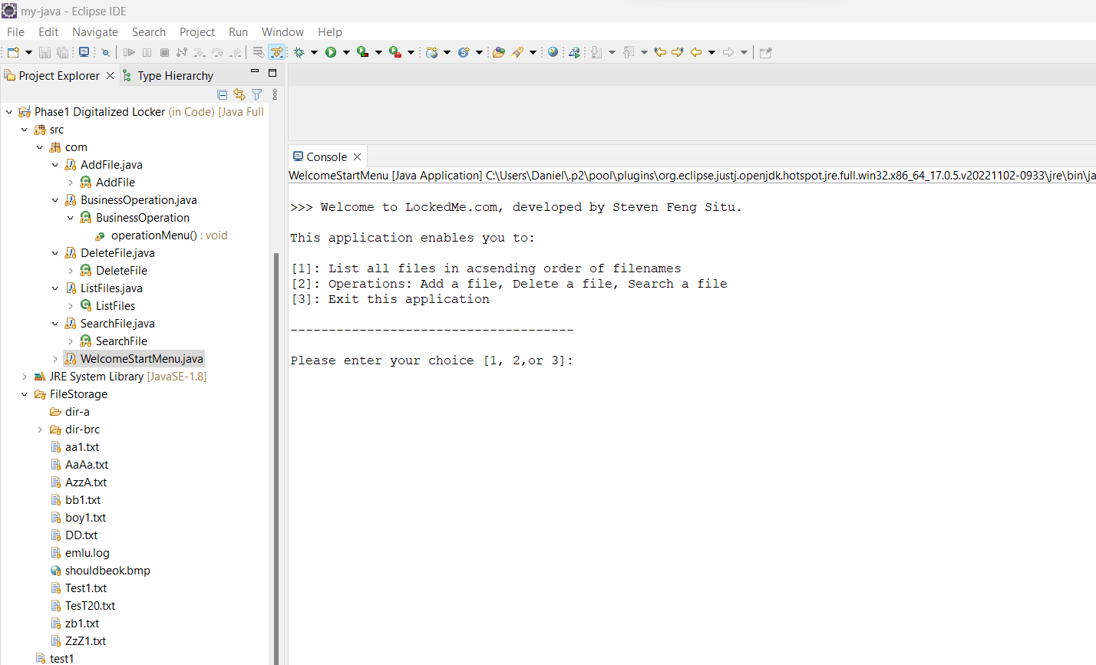

# 3. User select [1] list all files

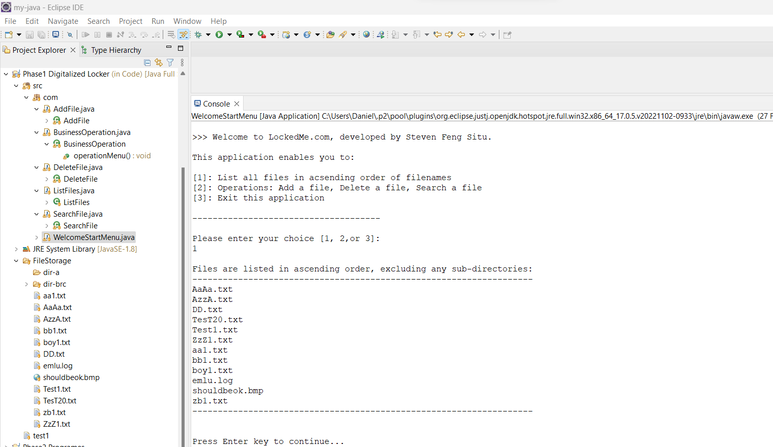

# 4. Select [2] for Business Operations sub-menu

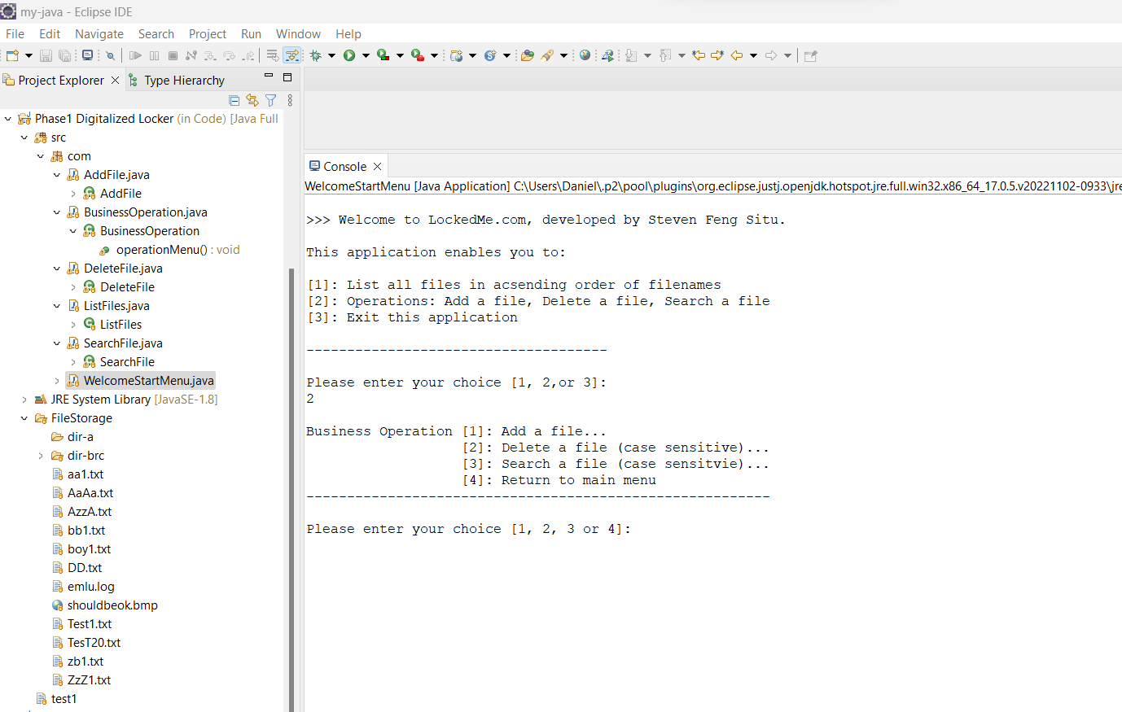

# 5. Select sub-menu [4] return to Main Welcome Menu

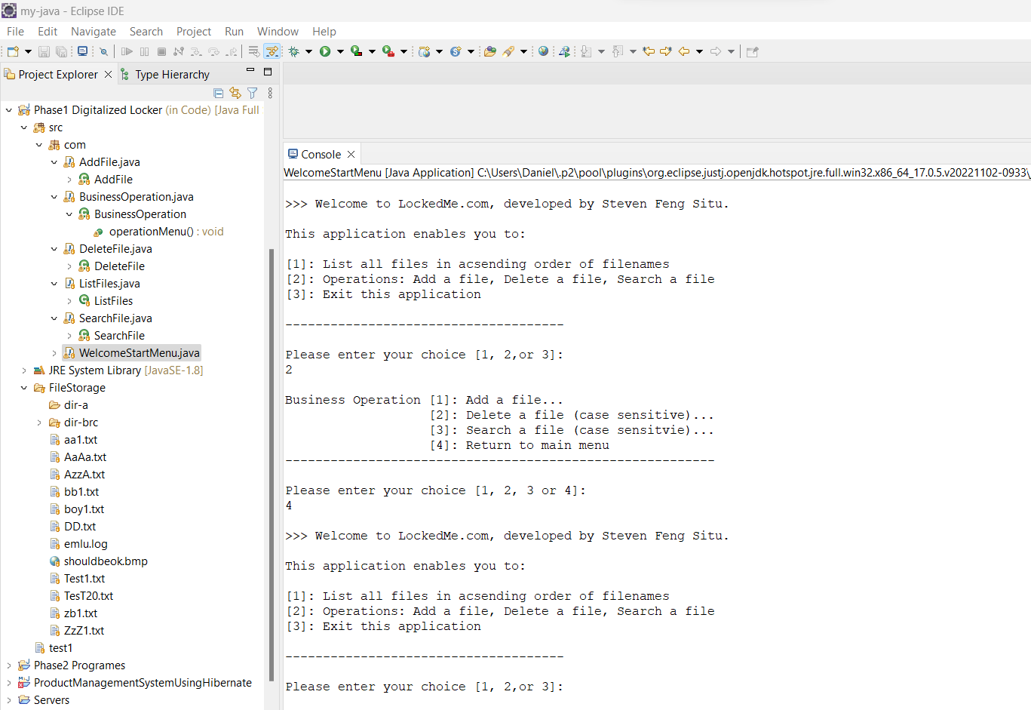

# 6. Main menu, select [3] to exit program

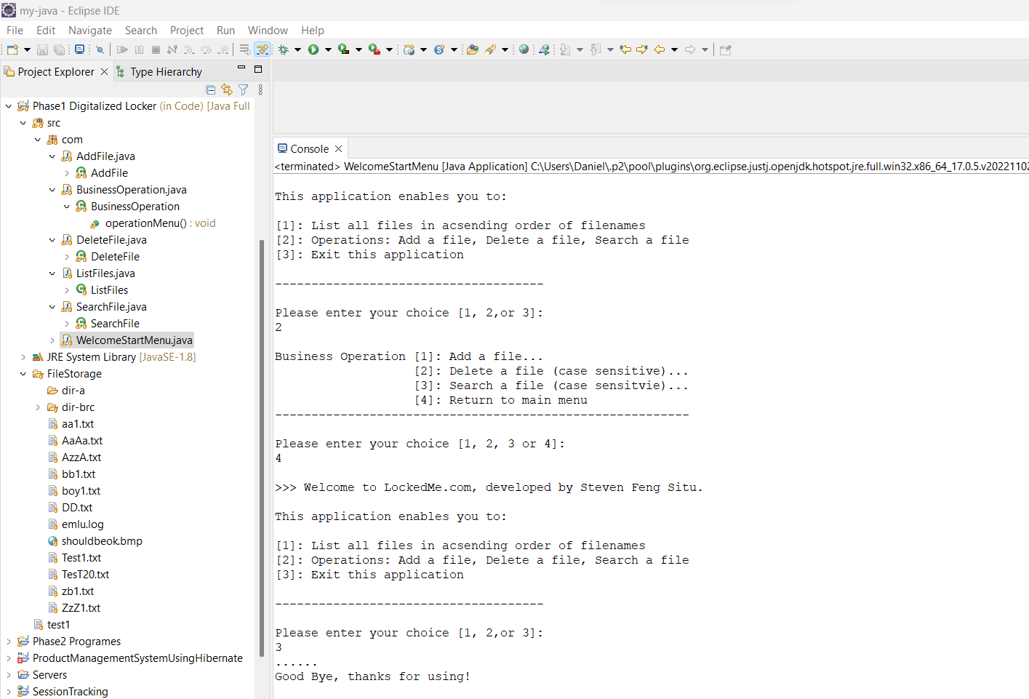

# 7. Business operation sub-menu, select [1] add a file, file already exists error

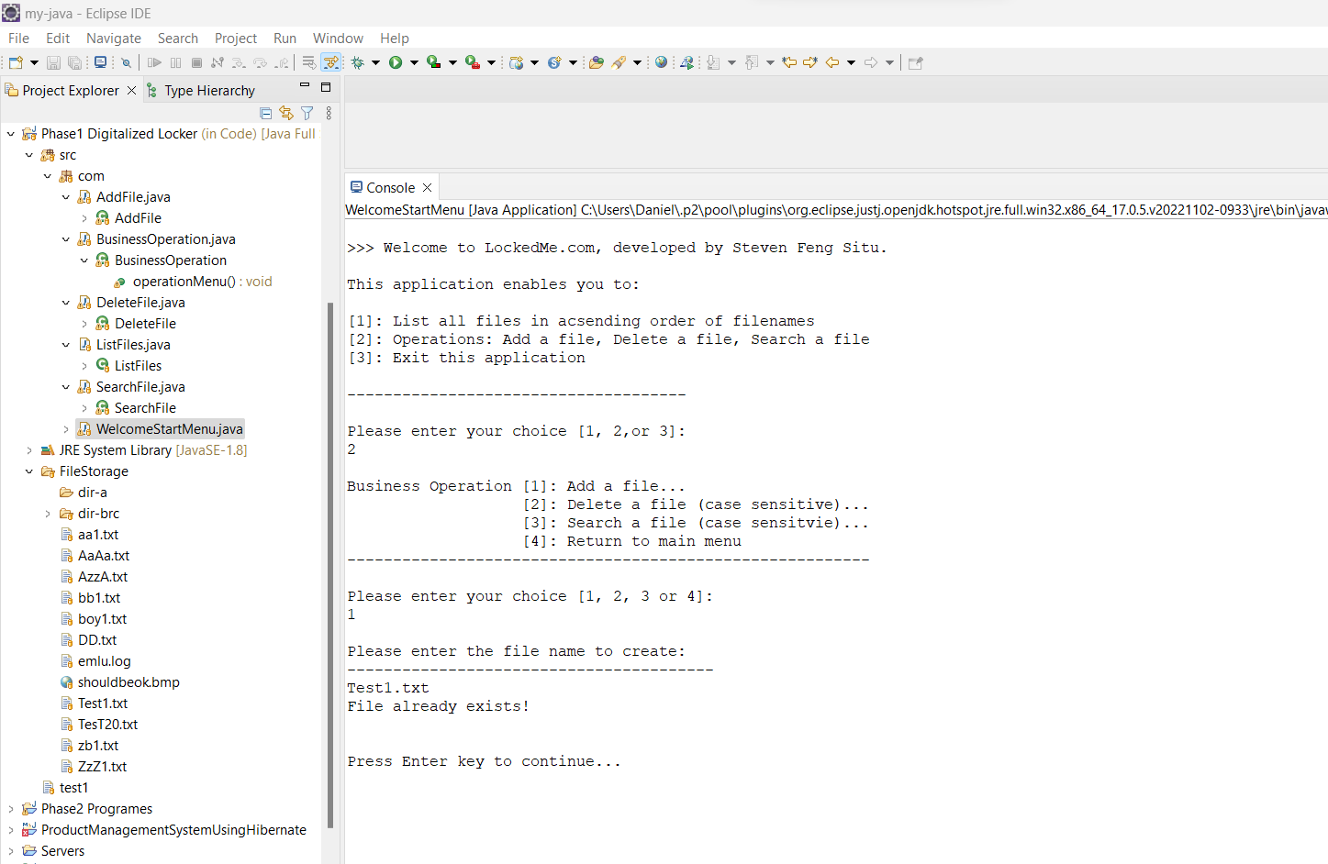

# 8. Business operation sub-menu , select [1] add a file, successful create a new file

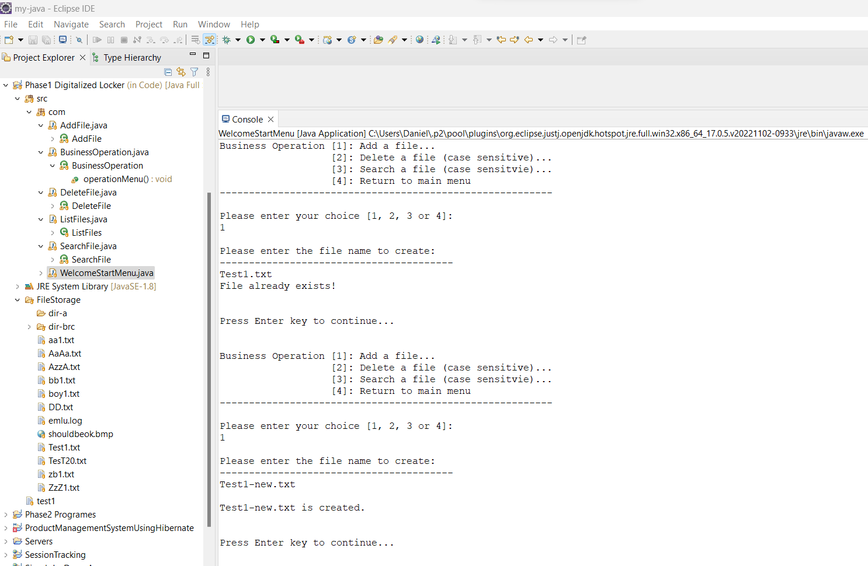

# 9. Business operation sub-menu , select [2] delete a file, file not found, no deletion

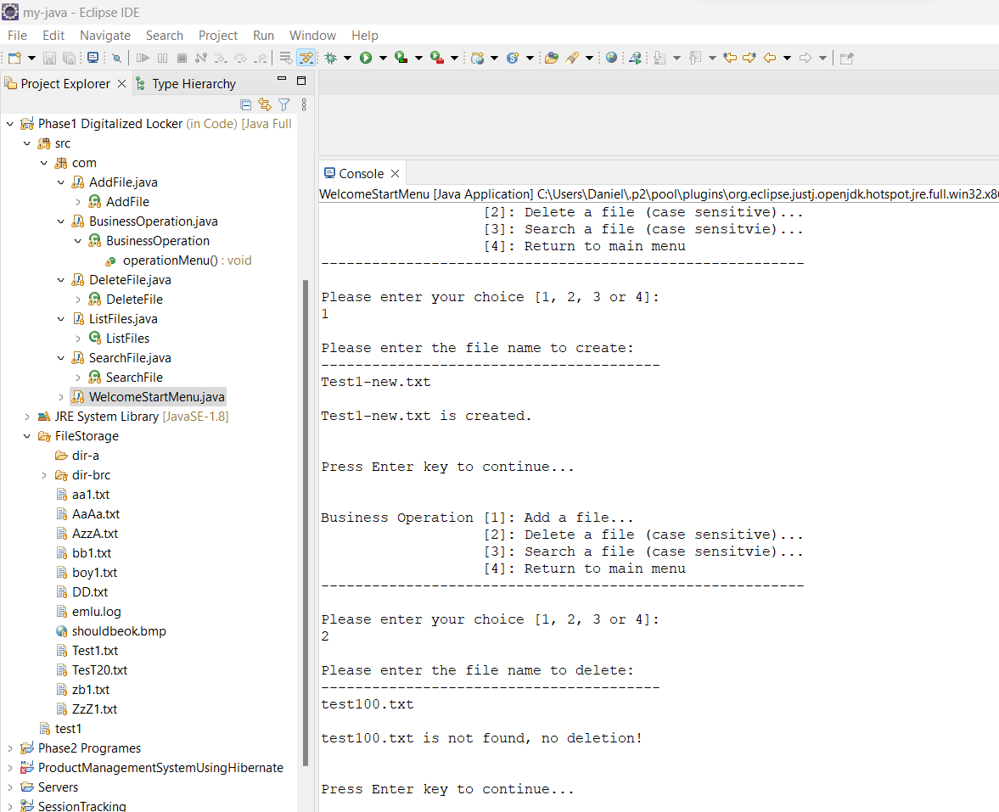

# 10. Delete a file , case-sensitive , miss-match as case-sensitive, no deletion

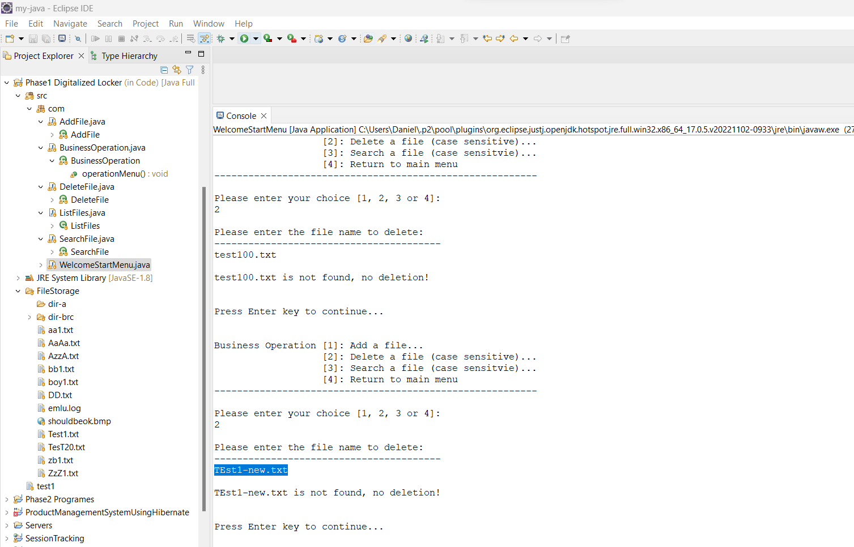

# 11. Delete a file , exact match , delete successfully

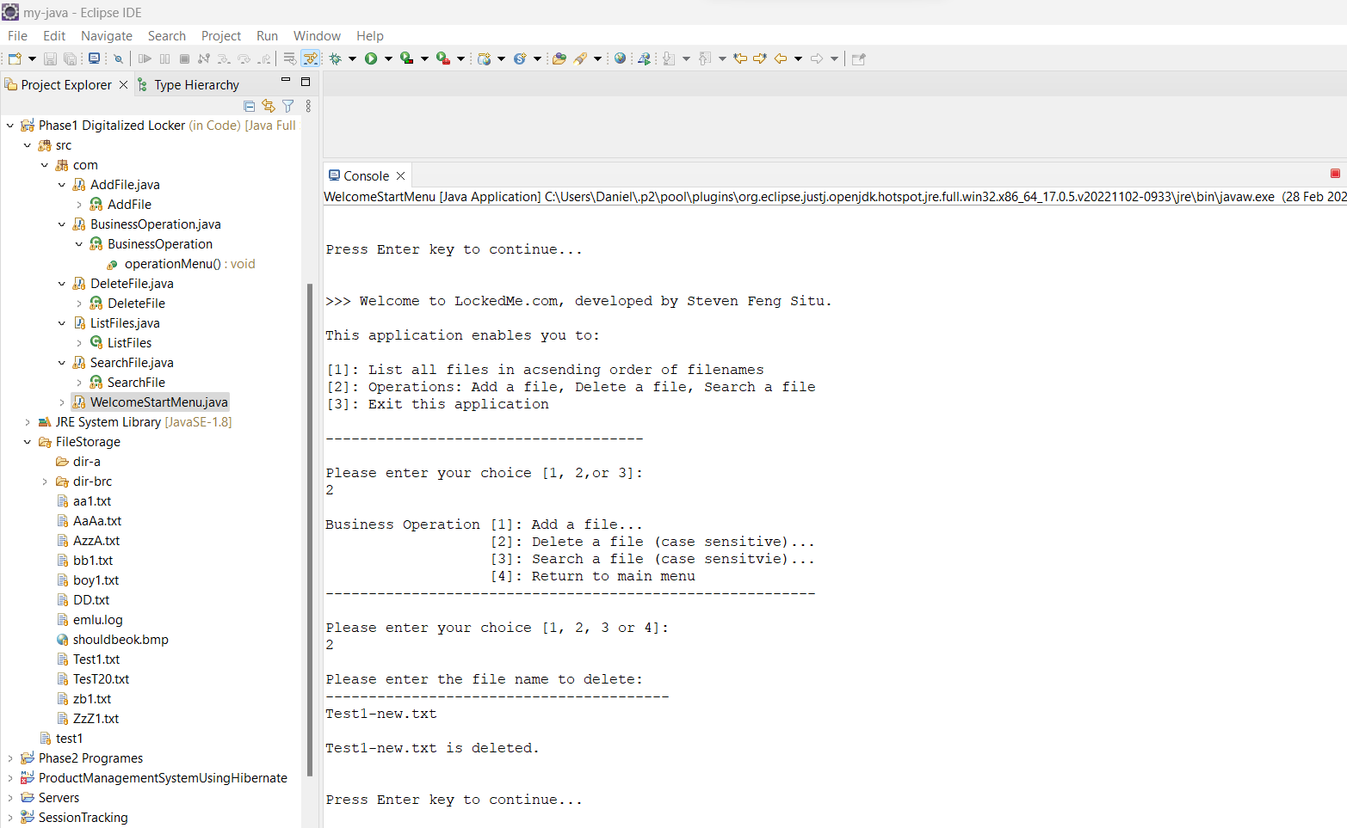

# 12. Business operation sub-menu [3], Search user specified file, success search

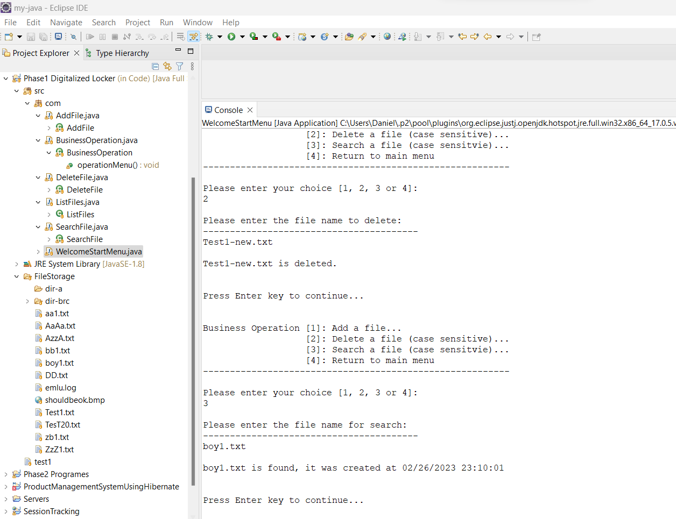

# 13. Sub-menu [3] , Search case-sensitive , miss-match , file not found

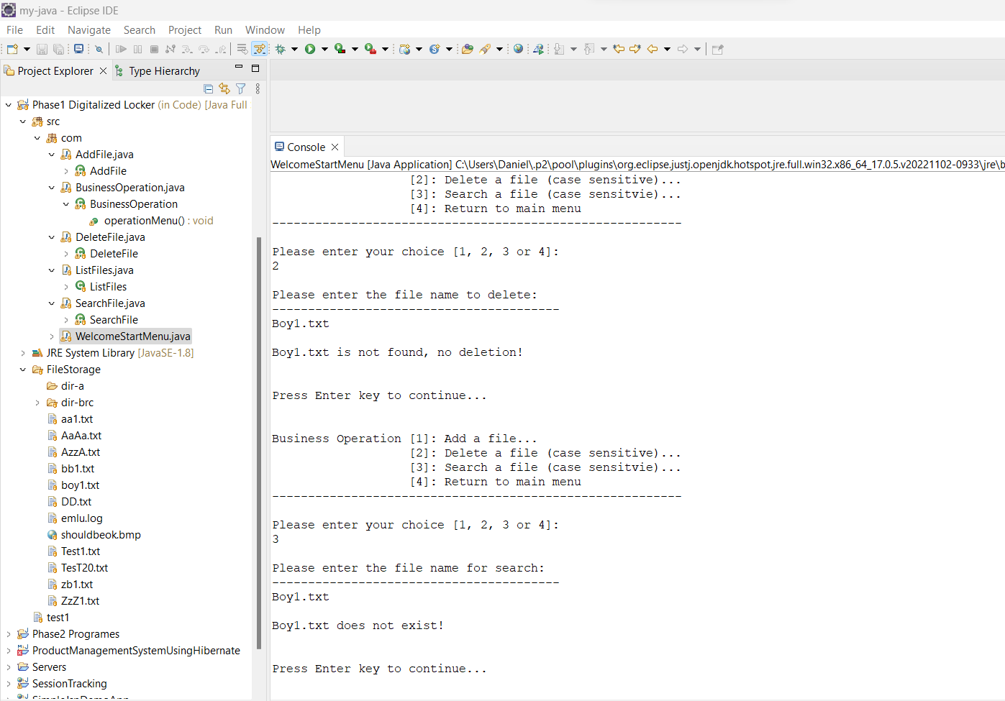

# 14. Sub-menu [4], return to Main Welcome Menu

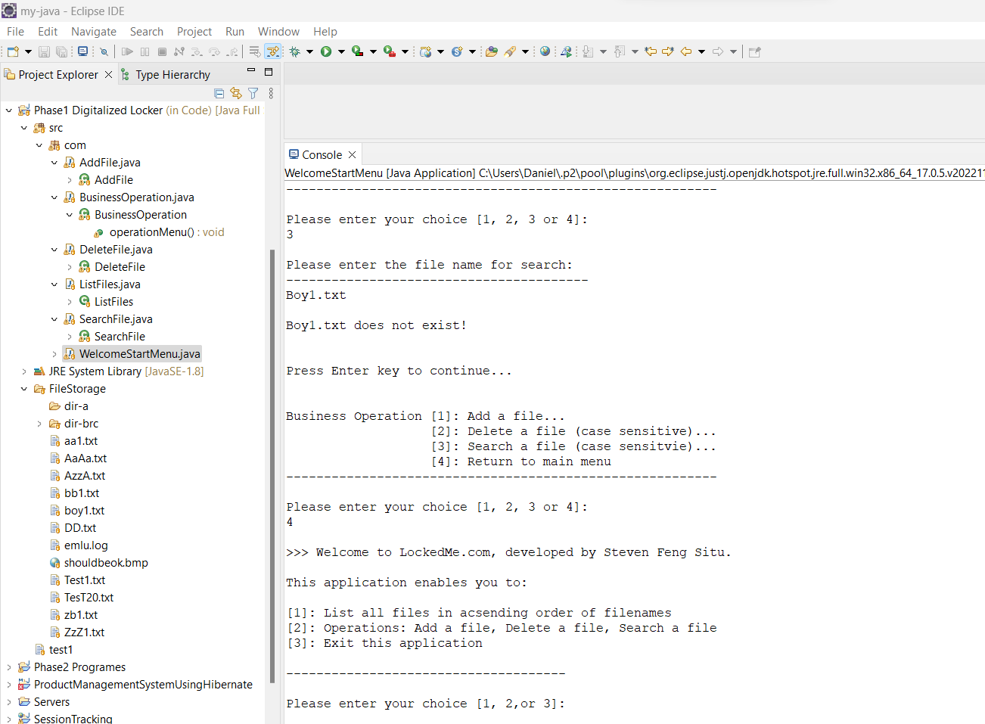

# 15. All operations exclude sub-directories , only applied to files

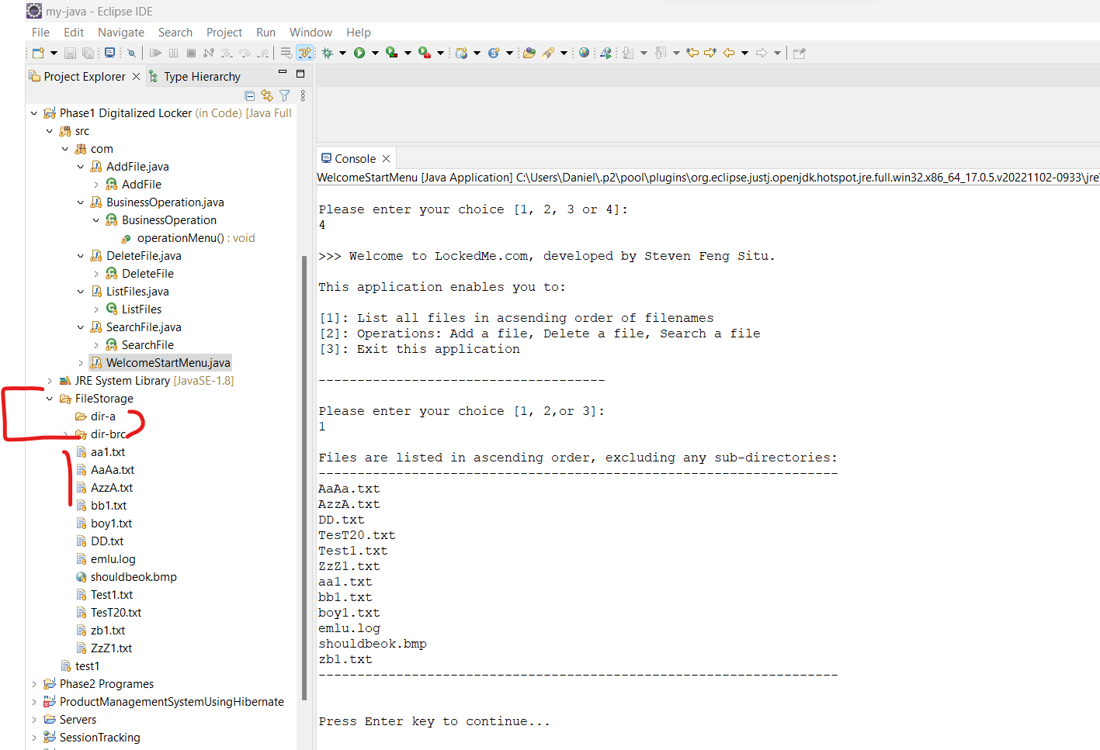

# 16. Main menu, user input outside of range , prompt to re-select

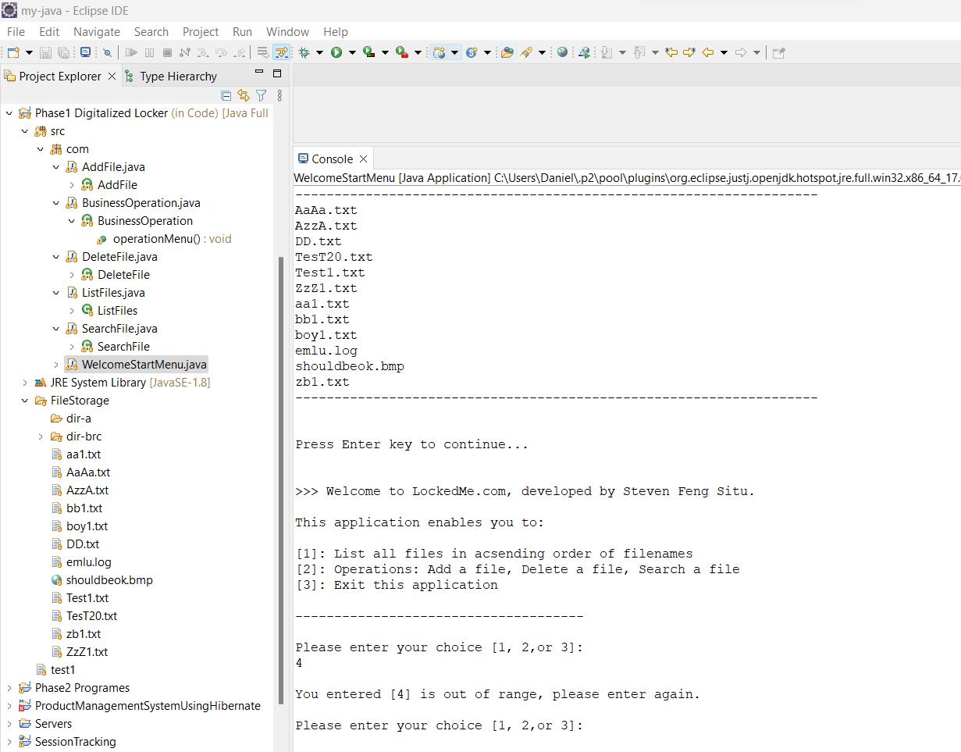

# 17. Business Operation sub-menu , user input out of range , prompt to re-select

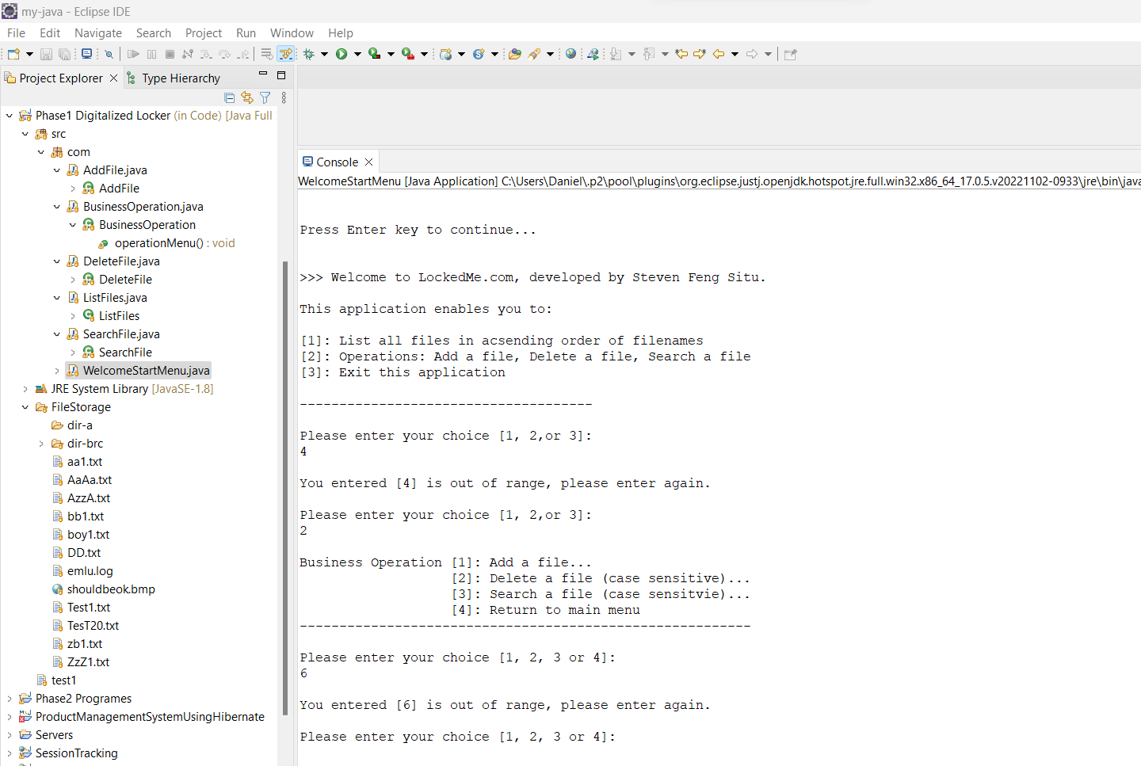

# 18. Remote git-hub and local repository

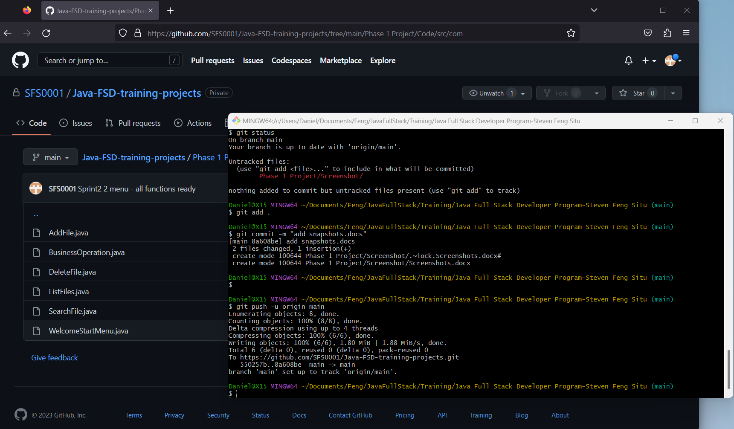

# 19. GitHub link,

https://github.com/SFS0001/Java-FSD-training-projects/tree/main/Phase%201%20Project